ICDS NUTRITION.
1.PROJECT OVERVIEW AND OBJECT :
The ICDS Nutrition project I have using cleaning, transforming and analysing raw data using Excel an interactive Power BI DASHBOARD
Improve the nutritional status of children (0–6 years), pregnant women, and lactating mothers through supplementary nutrition services. Using excel interactive PowerBI
Dashboard Visualization to make proper decision making .
2. DATA SOURCE
SOURCE DESCRIPTION :DATA GOVERNMENT/POSHAN-STATISTICS GOOGLE DATASET SEARCH AND 2025-2026
DOMAIN: The POSHAN Statistics based upon the nutritional and health status of beneficiaries under the Integrated Child Development Services (ICDS).. Etc
OBJECTIVE :
Monitor Anganwadi Performanc:
Track the functioning of Anganwadi Centres, workers, helpers, infrastructure, and service delivery across states, districts, projects, and sectors.
Analyse Nutrition & Health Indicators
Evaluate the nutritional status of children, pregnant women, and lactating mothers by analyzing malnutrition, stunting, wasting, obesity, and health ID coverage.
Measure Beneficiary Coverage
Assess Aadhaar verification, eligible beneficiaries, growth monitoring, attendance, supplementary nutrition (THR/HCM), and overall POSHAN program performance to support data-driven decisions.
4. ATTRIBUTE ICDS NUCTRTION OF DATASET AND TYPE

Attribute | Data Type | Description
Id | Integer | Unique identifier for each record.
Date | Date | Reporting date or month of the data.
state_name | Text | Name of the state.
state_code | Integer | Unique code assigned to the state.
district_name | Text | Name of the district.
district_code | Integer | Unique code assigned to the district.
Project | Integer | ICDS project code.
Sector | Integer | ICDS sector code.
anganwadi_centers | Integer | Total number of Anganwadi Centres (AWCs).
anganwadi_workers | Integer | Total number of Anganwadi Workers (AWWs).
anganwadi_helpers | Integer | Total number of Anganwadi Helpers (AWHs).
aadhar_verified_beneficiaries | Integer | Number of beneficiaries verified through Aadhaar.
eligible_beneficiaries | Integer | Total eligible beneficiaries under ICDS.
health_id_created | Integer | Number of Health IDs created for beneficiaries.
awc_infra_drink_water_src | Integer | Number of AWCs with drinking water facilities.
awc_infra_func_toilets | Integer | Number of AWCs with functional toilets.
awc_infra_own_building | Integer | Number of AWCs operating from their own buildings.
awc_did_not_open | Integer | Number of AWCs that did not open during the reporting period.
awc_open_atleast_1_day | Integer | Number of AWCs open for at least one day.
awc_open_atleast_15_days | Integer | Number of AWCs open for at least 15 days.
awc_open_atleast_21_days | Integer | Number of AWCs open for at least 21 days.
awc_open_atleast_25_days | Integer | Number of AWCs open for at least 25 days.
adolescent_girls | Integer | Number of adolescent girls enrolled as beneficiaries.
children_0_6_months | Integer | Number of children aged 0–6 months.
children_0_2_years | Integer | Number of children aged 0–2 years.
children_3_6_years | Integer | Number of children aged 3–6 years.
children_6_months_3_years | Integer | Number of children aged 6 months–3 years.
children_measured_0_5_years | Integer | Number of children aged 0–5 years whose growth was measured.
children_measured_0_6_years | Integer | Number of children aged 0–6 years whose growth was measured.
children_attend_awc_atleast_25_days | Integer | Number of children attending an AWC for at least 25 days.
hcm_given_1_6_days | Integer | Beneficiaries receiving Hot Cooked Meals (HCM) for 1–6 days.
hcm_given_7_14_days | Integer | Beneficiaries receiving Hot Cooked Meals for 7–14 days.
hcm_given_15_20_days | Integer | Beneficiaries receiving Hot Cooked Meals for 15–20 days.
hcm_given_atleast_1_day | Integer | Beneficiaries receiving Hot Cooked Meals for at least one day.
hcm_given_atleast_15_days | Integer | Beneficiaries receiving Hot Cooked Meals for at least 15 days.
hcm_given_atleast_25_days | Integer | Beneficiaries receiving Hot Cooked Meals for at least 25 days.
lactating_mothers | Integer | Number of lactating mothers registered.
pregnant_women | Integer | Number of pregnant women registered.
pregnant_women_and_lactating_mother | Integer | Total number of pregnant and lactating women (PLW).
obese_or_overweight | Integer | Number of beneficiaries identified as obese or overweight.
severely_moderately_underweight | Integer | Number of beneficiaries identified as severely or moderately underweight.
severely_or_moderately_stunted | Integer | Number of beneficiaries identified as severely or moderately stunted.
wasting_sam_or_mam | Integer | Number of children identified with Severe or Moderate Acute Malnutrition (SAM/MAM).
thr_given_atleast_1_day | Integer | Beneficiaries receiving Take Home Ration (THR) for at least one day.
thr_given_atleast_25_days | Integer | Beneficiaries receiving Take Home Ration for at least 25 days.
awc_mini | Integer | Number of Mini Anganwadi Centres.
awc_regular | Integer | Number of Regular Anganwadi Centres.
awc_rural | Integer | Number of rural Anganwadi Centres.
awc_urban | Integer | Number of urban Anganwadi Centres.
awc_total | Integer | Total number of Anganwadi Centres (Mini + Regular).
awc_tribal_rural | Integer | Number of tribal rural Anganwadi Centres.
awc_tribal_urban | Integer | Number of tribal urban Anganwadi Centres.
janman_rural | Integer | Number of rural AWCs covered under the PM JANMAN initiative.
janman_urban | Integer | Number of urban AWCs covered under the PM JANMAN initiative.
awc_rural_pvtg | Integer | Number of rural AWCs serving Particularly Vulnerable Tribal Groups (PVTGs).
awc_urban_pvtg | Integer | Number of urban AWCs serving Particularly Vulnerable Tribal Groups (PVTGs).

TOOLS &TECHNOLOGIES
Key Points
Tools and Technologies
- Microsoft Excel – Data collection, cleaning, and preprocessing.
- Power Query – Data transformation and ETL (Extract, Transform, Load).
- Power BI Desktop – Interactive dashboard creation and data visualization.
- DAX (Data Analysis Expressions) –Measures, and calculated columns.
- Data Modelling – Creating relationships between tables and optimizing the data model.
- ANG1 (One to One relationship state)
- ANG1 (One to One relationship health)
- Health (Many to Many relationships state)
- State (One to one relationship Ang1)
- CSV Files- There is three file ang1,health,state
6. Data Pre-Processing (Excel/Power Query)
Data Cleaning and Transformation: In power querry editor Promated Headers
Merged Queries: [Table.NestedJoin(#"Changed Type", {"id"}, state, {"id"}, "state_csv", JoinKind.LeftOuter)]
Expanded state: The state code column will be displayed (28,29,32,34,36) state code will be displayed
Mearged Queries: = Table.RenameColumns(#"Expanded state_csv1",{{"state_csv.state_code", "State code"}, {"state_csv.district_code",}
Expanded :District code will be displayed (745,744,502,753)
7.Data modelling and Dax (Power BI)
Establishing relationship between table
FROM: table(column) | Relationship | To: table(Column)
Health(district_name,state name) | Many to Many | state (district_name ,state,name)
Health(id) | One to One | ang1(id)
State(id) | One to One | ang1(id)

Screen short of data of modelling

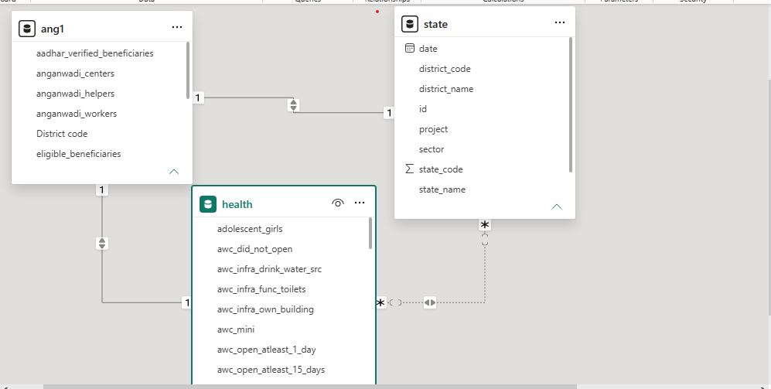
Calculate Column & DAX Measure
- ANG1:
- Aadhaar Verified = SUM(ANG1[aadhar_verified_beneficiaries])
- Eligible Beneficiaries = SUM(ANG1[eligible_beneficiaries])
- Total Workers = SUM(ANG1[anganwadi_workers])
- Worker per Centre = DIVIDE(SUM(ANG1[anganwadi_workers]), SUM(ANG1[anganwadi_centers]))
- Health:
- AWC Open Rate % = DIVIDE (SUM (health[awc_open_atleast_25_days]), SUM (health[awc_total]))
- Children 0-2 Years = SUM (health[children_0_2_years])
- Children 3-6 Years = SUM (health[children_3_6_years])
- Functional Toilet % = DIVIDE (SUM (health[awc_infra_func_toilets]), SUM(health[awc_total]),0)
- Total AWC = SUM (health[awc_total])
- Total Health IDs = SUM (health[health_id_created])
- Total Urban AWC = SUM (health[awc_urban])
- State:
- ANGNWADI WORKERE = CALCULATE(SUM (ang1[anganwadi_helpers])+sum(ang1[anganwadi_workers]),ALL(ang1))
Dashboard Features
1. KPI Cards
Provides a quick summary of important performance indicators.
- Total Anganwadi Workers (6M)
- AWC Open Rate (%) (0.27%)
- Count of children (0 to 6month) 296
- Count of children (0to 3 years)5M
- Count of children (6month to 3 years) 296
- Children (3–6 Years) 11M
2. Interactive Slicers
Allows users to filter the dashboard dynamically.
- Year (2025, 2026)
- Clear All Slicers button
3. Column Chart
Visualizes the availability of Anganwadi workers.
- District-wise Anganwadi Workers (Column Chart)
- Y-axis Count of District code (1 to4)
- X-axis Anganwadi Workers (0,0,6737,165,6931,164,18056,544, 18152,544)
4. Pie Chart -Infrastructure Analysis
Displays the availability of basic facilities in Anganwadi Centres.
- Own Building (29,600%)
- Functional Toilets (296)
- Drinking Water Source (296)
- Pie Chart for infrastructure distribution
5. stacked bar chart
Analyses health service coverage.
- Health ID Created by District (Horizontal Bar Chart) (2)
- District-level comparison of health services (Adilabad, Alappuzha, Alluri Sitharam Raju, etc)
6. Donut chart
Measures operational performance of centres.
- AWC Open Rate (21.8%,14.32%,13.25%,0.34%,27.98%,22.31%)
- Total AWC by State (Donut Chart) (139944,111492,108966,716562,66240,1710)
- State-wise operational comparison (Karnataka, Andhra Pradesh, Tamil Nadu, Telangana, Kerala, Puducherry)
List slicer
- Filter: Year (2025 to2026) and
- state wise (Tamil Nadu, Telangana, Karnataka, Andhra Pradesh, Kerala, Puducherry)
7.Clustered Column chart.
- Y-axis total workers (0.0M to 0.1M)
- X-axis state name (Tamil Nadu, Telangana, Karnataka, Andhra Pradesh, Kerala, Puducherry)
8.FUNNEL
VALUES: Anganwadi Centres. (1 to4)
Category: Anganwadi Workers (0 to 2050)
9. Stacked area chart Nutrition Analysis
Tracks maternal and child nutrition indicators.
- Obese/Overweight Children (8 to76)
- Pregnant Women (8 to 76)
- Lactating Mothers (8 to 76)
- State name (Tamil Nadu, Telangana, Karnataka, Andhra Pradesh, Kerala, Puducherry)
- Scatter/Line Chart for comparison
10. Functional Infrastructure Analysis
- Displays the availability of
- Functional Toilets,
- Own Buildings,
- Drinking Water Sources
- Count of awc total
- Count of awc rural
- Count of awc urban
- Visualization Used: Stacked Bar Chart
- State code (28 to 36)
11.Table
- Maternal Health Analysis And adolescent girls (294 to 4287)
- Shows the count of Pregnant Women (1) and Lactating Mothers. (1)
- Displays the number of Children (0–2 Years) (4274 to22201) and Children (0–6 Months) (1)
12.GAUGE
- . The dashboard displays 2,048 eligible beneficiaries as the current value.
- The gauge indicates progress against a target of 4,096 beneficiaries, showing that approximately 50% of the target has been achieved.
13.KPI CARD
- Aadhaar Verified Beneficiaries and Health IDs Created.
- It helps identify beneficiaries who have completed Aadhaar verification and digital health registration.
14.Area chart
- Health id created (0 to13)
- Count of Aadhar verified beneficiaries (1,2,3,5,6,8,12,27)
- Count of eligible beneficiaries (1,2,3,5,6,8,12,27)
15.Map state wise count of pregnant women
- State (Tamil Nadu, Telangana, Karnataka, Andhra Pradesh, Kerala, Puducherry)
- Count of pregnant women (2048)
16.Matric
- Column (Anganwadi Workers, Anganwadi helpers (0to 734)
- State (Tamil Nadu, Telangana, Karnataka, Andhra Pradesh, Kerala, Puducherry)
17.Slicer.
- State name (Tamil Nadu, Telangana, Karnataka, Andhra Pradesh, Kerala, Puducherry)
Screenshot of dashboard page 1
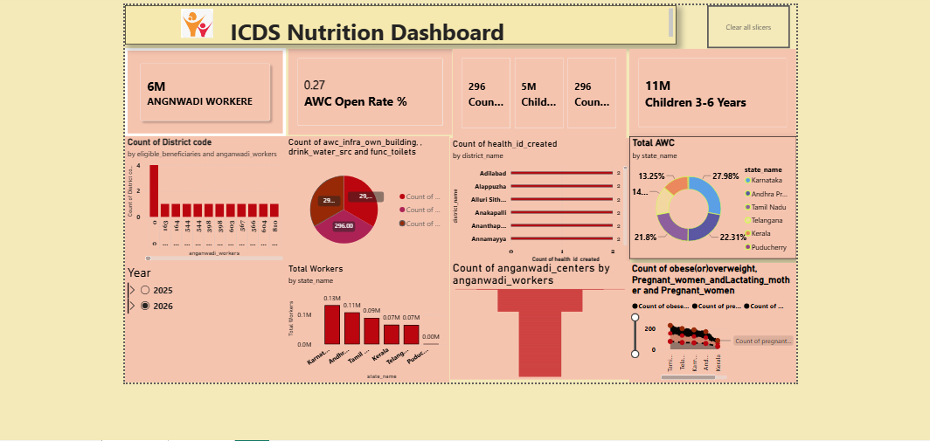

Screenshot of dashboard page 2

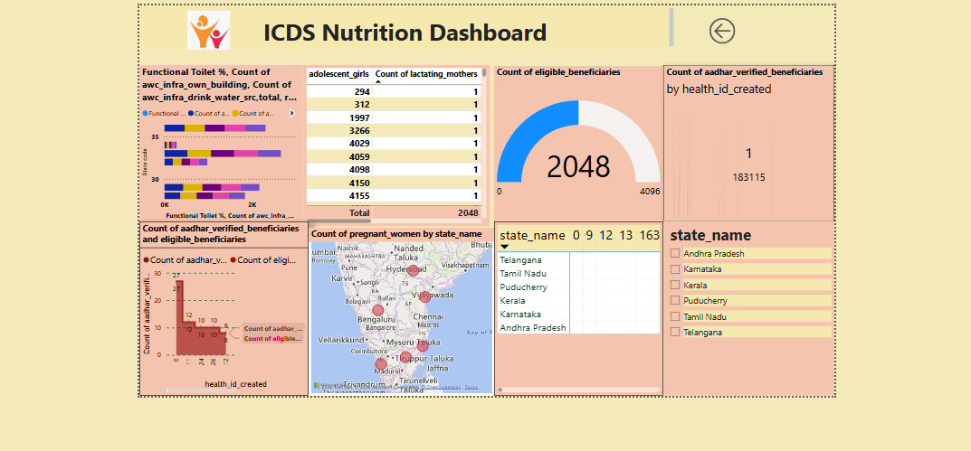

9.Insight & Conclusins
Overall Key Findings
- Around 6 million Anganwadi workers support ICDS service delivery.
- Approximately 11 million children (3–6 years) are covered by nutrition services.
- AWC Open Rate (27%) suggests scope for improving operational performance.
- Infrastructure availability differs across states, particularly in sanitation and drinking water facilities.
- Digital initiatives such as Health ID creation and Aadhaar verification improve beneficiary tracking.
- Beneficiary coverage includes children, pregnant women, lactating mothers, and adolescent girls.
- Geographic analysis State wise and service delivery.
- Interactive drill-through pages provide detailed analysis for infrastructure, beneficiaries, and verification status.

Descriptive Analytics
The dashboard summarizes key ICDS metrics such as Anganwadi workers, AWC open rate, beneficiary counts, infrastructure, and nutrition indicators. It provides a clear overview of programme performance across states and districts.

Diagnostic Analytics
The dashboard helps identify reasons for performance differences by comparing workforce, infrastructure, Health ID creation, and Aadhaar verification across regions.

Predictive Analytics
Historical trends and beneficiary data can be used to forecast future demand for Anganwadi services, workforce requirements, and beneficiary coverage. Predictive insights help anticipate resource needs and programme growth.

Prescriptive Analytics
The dashboard supports decision-making by highlighting areas requiring improved infrastructure, increased workforce, or enhanced beneficiary verification.

Conclusion
The ICDS Nutrition Dashboard provides an interactive and comprehensive view of Anganwadi performance, beneficiary coverage, infrastructure, and health indicators, enabling effective programme monitoring. It supports data-driven decision-making by helping stakeholders identify service gaps, compare state performance, and improve the delivery of nutrition and child welfare services.

